**PROJECT REPORT**

Project title

**Data Visualization and Inference Modelling**

**The Case of Nifty**

**Industrial Project Based Learning**

**Capstone Project**

By

**TEAM 7**

**Team Members:**

CHINTA SAI RANGANATH 22R15A6703

SIDRAMYNA RATHNAKAR 22R15A6707

MARIPALLI FARIDUDDIN 21R11A6730

LUNAVATH THIRUPATHI 22R15A6705

NANDIGAMA LIKITH CHOWDARY 21R11A6739

KOTA AMITH 21R11A6724

**Geethanjali College of Engineering and Technology**

**Cheeryal, Keesara, 500085, Telangana**

**APRIL 2024**

**ABSTRACT**

In this study, we're delving into the Nifty index returns, which represent the performance of the stock market in India, over a period spanning from January 2000 to December 2023. Our primary aim is to gain deeper insights into the behaviour of the Nifty index and understand the factors influencing its fluctuations. To achieve this, we're leveraging various data analysis techniques. Heatmaps allow us to visually represent the Nifty returns for each month over the entire duration of our dataset. This visualization technique helps us identify patterns and trends in the data, such as periods of high or low returns, which can be crucial for investors in making informed decisions. Histograms, on the other hand, provide a different perspective by illustrating the distribution of Nifty returns across different ranges or "buckets." By dividing the returns into these buckets, we can observe how frequently certain ranges of returns occur, giving us a better understanding of the overall distribution and volatility of the market.

Moreover, we're conducting a detailed analysis of seasonal patterns, trends, and fluctuations in Nifty returns. By examining how Nifty returns behave during specific months or seasons, we can uncover recurring patterns or anomalies that may offer valuable insights into market dynamics. Additionally, we're exploring the impact of significant events, such as economic crises and the COVID-19 pandemic, on Nifty returns. These events can have profound effects on market sentiment and investor behaviour, leading to sharp fluctuations or prolonged periods of volatility. Furthermore, we're developing predictive models, to forecast future Nifty returns based on historical data. These forecasts can aid investors in anticipating market movements and adjusting their investment strategies accordingly.

**TABLE OF CONTENTS**

|  |  |  |
| --- | --- | --- |
| **S.NO** | **TOPICS** | **PAGE NUMBERS** |
| i | Abstract | i |
| 1 | Introduction | 1 |
| 2 | Literature survey | 2 |
| 3 | Problem statement | 2 |
| 4 | Objectives | 2 |
| 5 | Methodology | 3 |
| 5.1 | Data collection | 3 |
| 5.2 | Importing dataset and required packages | 4 |
| 6 | Exploratory data analysis | 5 |
| 6.1 | Heat map for Monthly returns | 5 |
| 6.2 | Histogram for Monthly returns | 8 |
| 6.2.1 | Bar plot Analysis | 8 |
| 6.2.2 | Curve plot Analysis | 9 |
| 6.2.3 | Standard Deviation bins Analysis | 10 |
| 6.3 | Histogram for Annual returns | 15 |
| 7 | Time series Analysis | 17 |
| 8 | Model Evaluation | 19 |
| 9 | Building Web application | 20 |
| 9.1 | Forecast Prediction Application | 20 |
| 9.2 | Histogram Plot Application | 21 |
| 9.3 | Time Series Analysis Application | 21 |
| 10 | Result | 22 |
| 10.1 | Result for Forecast Prediction Application | 22 |
| 10.2 | Result for Histogram Plot Application | 24 |
| 10.3 | Result for Time Series Analysis Application | 26 |
| 11 | Conclusion | 27 |
| 12 | References | 27 |

**TABLE OF FIGURES**

|  |  |  |
| --- | --- | --- |
| **S.NO** | **FIGURE NAME** | **PAGE NO** |
| 5.1 | Columns with Null Values | 4 |
| 5.2 | Visualization of Null values | 4 |
| 6.1.1 | Heat Map for Monthly returns | 5 |
| 6.1.2 | March 2020 return values (Covid) | 7 |
| 6.2.1 | Histogram of Month Feature | 8 |
| 6.2.2 | Histogram curve plot for Month feature | 9 |
| 6.2.3 | Histogram plot for standard deviation bins of march month | 10 |
| 6.2.4 | Histogram plot for standard deviation bins of jan month | 11 |
| 6.2.5 | Histogram plot for standard deviation bins of feb month | 11 |
| 6.2.6 | Histogram plot for standard deviation bins of apr month | 12 |
| 6.2.7 | Histogram plot for standard deviation bins of may month | 12 |
| 6.2.8 | Histogram plot for standard deviation bins of jun month | 12 |
| 6.2.9 | Histogram plot for standard deviation bins of jul month | 13 |
| 6.2.10 | Histogram plot for standard deviation bins of aug month | 13 |
| 6.2.11 | Histogram plot for standard deviation bins of sep month | 13 |
| 6.2.12 | Histogram plot for standard deviation bins of oct month | 14 |
| 6.2.13 | Histogram plot for standard deviation bins of nov month | 14 |
| 6.2.14 | Histogram plot for standard deviation bins of dec month | 14 |
| 6.3.1 | Histogram bar plot for annual returns | 15 |
| 6.3.2 | Histogram curve plot for annual returns | 15 |
| 6.3.3 | Histogram standard deviation bins plot for annual returns | 16 |
| 7.1 | Trend, Seasonal plots for year 2020 | 17 |
| 7.2 | Trend, Seasonal plots for year 2008 | 18 |
| 9.1 | Input for Forecast Prediction Application | 20 |
| 9.2 | Input for Histogram Plot Application | 21 |
| 9.3 | Input for Time Series Analysis Application | 21 |
| 9.4 | Running Flask application on localhost | 22 |
| 10.1 | Web address of Flask Application | 22 |
| 10.2 | Input filed 1 | 23 |
| 10.3 | output prediction 1 | 23 |
| 10.4 | Input filed 2 | 24 |
| 10.5 | output prediction 2 | 24 |
| 10.6 | output prediction 3 | 25 |
| 10.7 | output prediction 4 | 25 |
| 10.8 | Input filed 3 | 26 |
| 10.9 | output prediction 5 | 26 |

1. **Introduction**

In today's financial world, knowing where the market is headed, we can make a huge difference for investors, analysts, and policymakers. With technology making data analysis easier, we can now dive deep into financial data to uncover trends and predict future outcomes. In this study, we're focusing on time series analysis, a method for looking at data collected over time, particularly on the Nifty index, which tracks the performance of 50 Indian company stocks from January 2000 to December 2023.

By reviewing existing research and techniques used in financial data analysis, we'll learn how experts analyse stock market data to understand market behaviour and predict future trends.

Heatmaps and histograms are indispensable tools in the realm of data analysis, offering intuitive visualizations that greatly aid in understanding complex datasets such as Nifty index returns. Heatmaps, with their color-coded representations, offer a comprehensive view of return trends over time. By assigning different colours to varying return values, they enable quick identification of patterns, outliers, and trends. This visualization method facilitates comparisons across different time periods and helps in pinpointing seasonal trends or abnormal market behaviour.

On the other hand, histograms provide insights into the distribution of returns by showcasing how frequently certain return ranges occur. By dividing returns into bins or intervals and plotting the frequency of occurrences within each bin, histograms offer a clear depiction of return variability and risk. They can reveal the probability of specific return outcomes and highlight the volatility or stability of the market. Additionally, histograms enable analysts to assess the likelihood of extreme returns and fluctuations, thereby informing risk management strategies.

In summary, heatmaps and histograms serve as indispensable tools for financial analysts, offering intuitive visualizations that simplify the exploration and interpretation of Nifty index returns data. Through these visualizations, analysts can uncover trends, patterns, and anomalies, ultimately enhancing decision-making processes and risk assessment strategies.

1. **Literature Survey**

Time Series Analysis in Financial Markets: In the world of finance, experts often use time series analysis to understand how stock markets, like Nifty, change over time. They use methods like ARIMA models and machine learning to predict how markets might behave in the future.

Impact of Economic Crises on Financial Markets: Economic crises, like recessions or major events such as the 2008 financial crisis or the COVID-19 pandemic, can shake up financial markets. Studies have looked into how these crises affect markets, especially how stock prices go up or down.

1. **Problem Statement**

The problem we're tackling is understanding how the Nifty returns have behaved over the years and predicting how they might perform in the future. We're delving into historical data from 2000 to 2023 to uncover any trends or patterns, especially focusing on how events like economic crises or the COVID-19 pandemic have affected the market using heatmap and histograms. By using techniques like the ARIMA model, we aim to forecast future market conditions. Additionally, we're creating user-friendly web tools to make this data accessible and help investors make informed decisions. Essentially, we're trying to understand the past, predict the future, and make investing easier for everyone.

1. **Objective**

* Generate a heatmap illustrating the monthly returns of Nifty.
* Construct histograms displaying the distribution of monthly returns, categorized into five or more buckets.
* Develop a histogram showcasing the distribution of yearly returns, also segmented into five or more buckets.
* Analyses seasonal patterns, trends, and fluctuations in Nifty returns over time, with a specific focus on significant events like economic crises and the COVID-19 pandemic.
* Build predictive models to forecast future Nifty returns using historical data.

1. **Methodology**

**5.1 Data Collection**

* The dataset has 14 features and 24 columns observation.
* The dataset contains Nifty returns spanning from January 2000 to December 2023, recorded on a monthly basis as well as annually.

**Datatype of each feature**

These are the feature names and their datatype.

|  |  |  |
| --- | --- | --- |
| S.No | Feature Name | **Data Type** |
| 1 | Year | Numerical variable |
| 2 | Jan | Numerical variable |
| 3 | Feb | Numerical variable |
| 4 | Mar | Numerical variable |
| 5 | Apr | Numerical variable |
| 6 | May | Numerical variable |
| 7 | Jun | Numerical variable |
| 8 | Jul | Numerical variable |
| 9 | Aug | Numerical variable |
| 10 | Sep | Numerical variable |
| 11 | Oct | Numerical variable |
| 12 | Nov | Numerical variable |
| 13 | Dec | Numerical variable |
| 14 | Annual | Numerical variable |

* 1. **Importing dataset and required packages**

**Pandas, NumPy, Matplotlib, Seaborn**, and **Statsmodels** are the libraries which are used for this dataset. The dataset is loaded using Pandas library, NumPy library is used to handle numerical computing, Seaborn and Matplotlib is used to visualize the data distributions, trends, and relationships. Finally, statsmodel is used to forecast the values from past data.

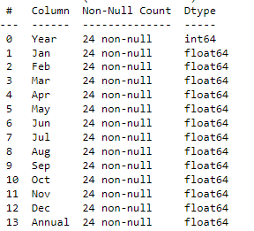

Fig 5.1 Columns with Null Values

The figure confirms that there are no missing values in the dataset, and this is visually shown as well below:

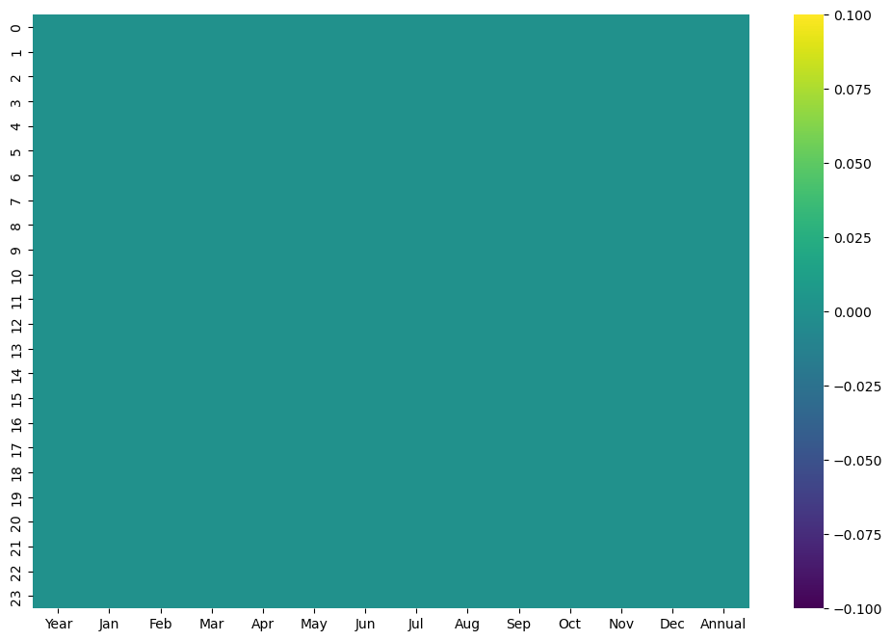

Fig 5.2 Visualization of Null values

Here the figure too shows visually that there are no null values in the dataset.

As the dataset is about Nifty returns which comprise real-time data, it is evident that we can say that there are no outliers present in the dataset.

1. **EXPLORATORY DATA ANALYSIS**

Exploratory Data Analysis (EDA) is an essential step in the machine learning process, where the main goal is to analyse and understand the characteristics of the data before applying any modelling techniques. EDA is the process of summarizing the main characteristics of the data, such as the distribution, the relationship between variables, and identifying any patterns or anomalies that may exist.

The primary focus of the project involves creating a heatmap to analyse patterns and relationships within the dataset. Additionally, the project entails generating histograms to examine the distribution of data across different bins for both monthly and annual features. These visualizations serve as essential tools for understanding the data's characteristics and uncovering insights.

* 1. 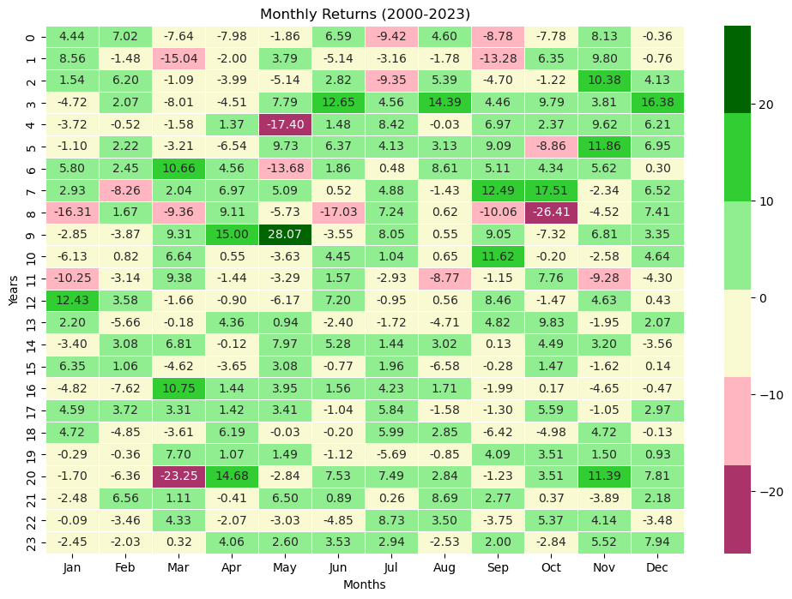**Heat map for Monthly returns**

Fig 6.1.1 Heat Map for Monthly returns

The above heatmap visually specifies the Nifty returns for each month spanning from 2000 to 2023.

* Dark green represents Nifty returns exceeding 20.
* Green represents Nifty returns ranging from 10 to 20.
* Light green represents Nifty returns between 0 and 10.
* White represents Nifty returns between -10 and 0.
* Light pink represents Nifty returns between -10 and -20.
* Dark pink is used for Nifty returns less than -20.

Nifty returns exceeding 20% which represents exceptionally high-profit returns.

Nifty returns between 10% and 20% suggest robust market growth, indicating favourable investment conditions.

Nifty returns between 0% and 10% signify moderate market growth, reflecting stable investment conditions.

Nifty returns between -10% and 0% indicate a slight downturn in the market, suggesting minor losses or fluctuations.

Nifty returns between -10% and -20% represent a notable market decline, possibly signalling a period of correction or instability.

Nifty returns less than -20% denote a significant market downturn, indicating substantial losses and potential financial risk.

**Observations**:

* As from the heatmap we can observe that the months April, December having the Nifty returns high profits, favourable market growth and also moderate growth from 2000 to 2023.
* Similarly, the month September have moderate growth returns and slight downturn in the market based on Nifty returns.

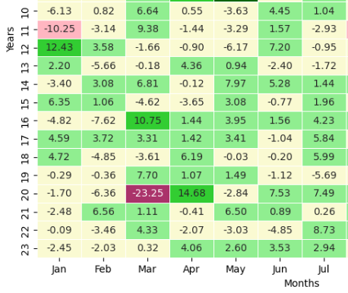

Fig 6.1.2 March 2020 return values(Covid)

* **Observations of March Month 2020 (During COVID Pandemic)**

The above figure shows the Nifty returns specifically for the month of March in 2020. As the dataset is real time data the returns it's evident that during this period, the Nifty returns experienced a sharp decline or downfall or downturn due to various factors such as global economic uncertainty, market volatility, and the impact of the COVID-19 pandemic.

* **Observations of April Month 2020 (During COVID Pandemic)**

The Nifty experienced a rise in April 2020 following the downfall in March 2020, primarily due to several factors like Technology and Pharma Sector Performance. During the COVID-19 pandemic, certain sectors such as technology and pharmaceuticals witnessed increased demand for their products and services. Companies within these sectors, which are prominent components of the Nifty index, saw their stock prices rise as they adapted to changing market conditions and benefitted from increased consumer demand.

As the new services sector got used by consumers during pandemic the nifty returns doesn’t affect much badly for other months compare to March month.

Similarly, the nifty returns got downfall due to effect of new government rules and regulations during the October of 2008 and May of 2004.

During May 2009 the nifty returns got increased due to global financial markets were beginning to recover from the depths of the 2008 financial crisis and due to Government Policies, Improved Market Sentiment.

* 1. **Histogram for Monthly returns**

As we generated the Histograms plots for all features in the dataset, we have shown a particular focus on the month of March. This emphasis on March is crucial because it allows us to examine the impact of the COVID-19 pandemic crisis.

* + 1. **Bar plot Analysis**

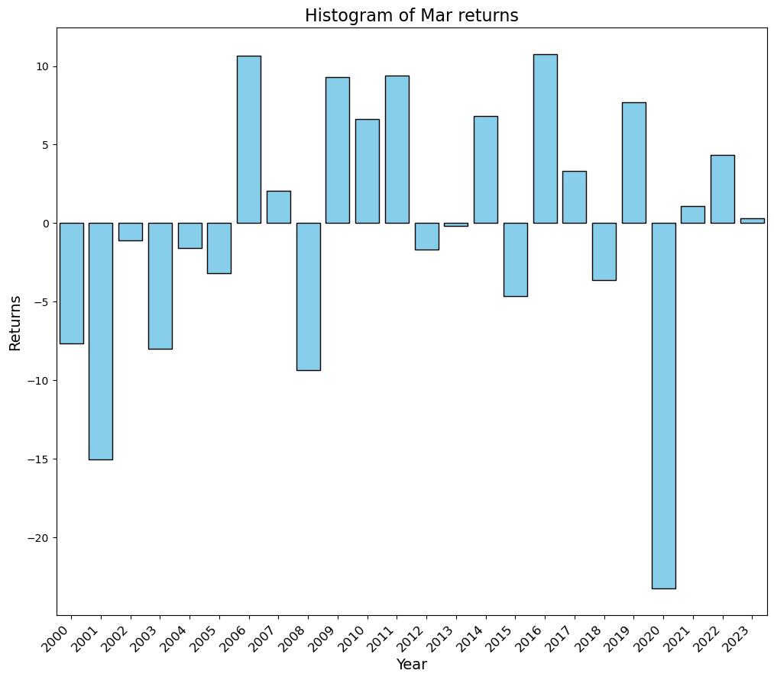

Fig 6.2.1 Histogram of Month Feature

The above bar graphs visually represent the Nifty returns for March month from 2000 to 2023.

The bars represent the Nifty return on that particular year. From the figure we can see that the Nifty have taken a huge downfall due to effect of Covid crisis.

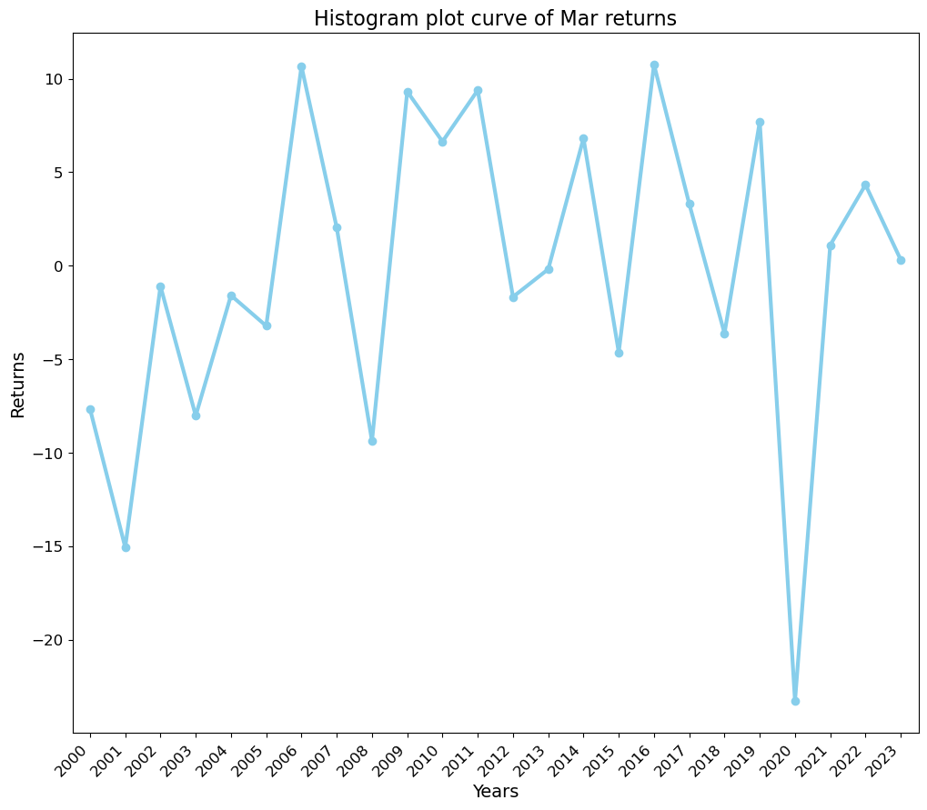**6.2.2** **Curve plot Analysis**

Fig 6.2.2 Histogram curve plot for Month feature

Similar to the previous analysis, we generated a curve representing Nifty returns for the month of March across different years.

Notably, the curve for the year 2020 shows a significant downturn, which can be attributed to the impact of the Covid pandemic.

When plotting a histogram, standard deviation buckets or bins are used to group data points into intervals based on their standard deviation from the mean. This helps to visualize the distribution of the data and identify any patterns or trends. In simpler terms, it's like dividing the data into groups where each group represents a certain range of standard deviation from the average value. This allows us to see how spread out the data is and how much variation there is from the average.

* + 1. 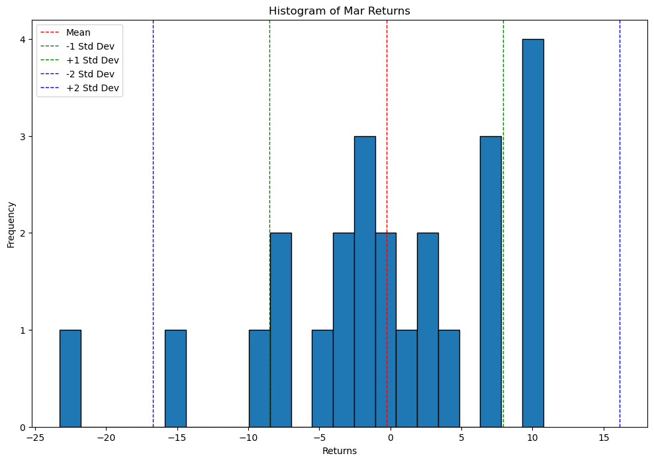**Standard Deviation bins Analysis**

Fig 6.2.3 Histogram plot for standard deviation bins of march month

The above graphs represent the plotting based on standard deviation buckets or bins.

In this analysis, data is grouped into intervals based on their standard deviation, ranging from +2 to -2. The graph visually represents these standard deviation bins and their corresponding number of years with Nifty returns falling within each interval:

Standard deviation less than 2: One-year Nifty return.

Standard deviation between -1 to +1: Seventeen years of Nifty returns.

Standard deviation between -1 to -2: One year of Nifty return.

Standard deviation between +1 to +2: Four years of Nifty returns.

Standard deviation greater than 2: No year have Nifty return.

By grouping the data into standard deviation bins, we can assess the concentration of Nifty returns within different ranges of deviation from the average. Observing that the majority of years fall within the -1 to +1 standard deviation range suggests that Nifty returns typically stay within a relatively narrow band around the mean return.

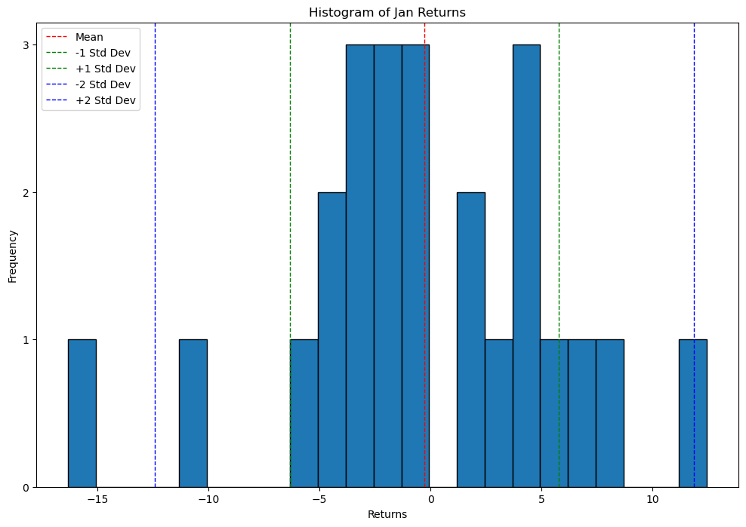Similarly, the same plots are represented for all the months in the dataset.

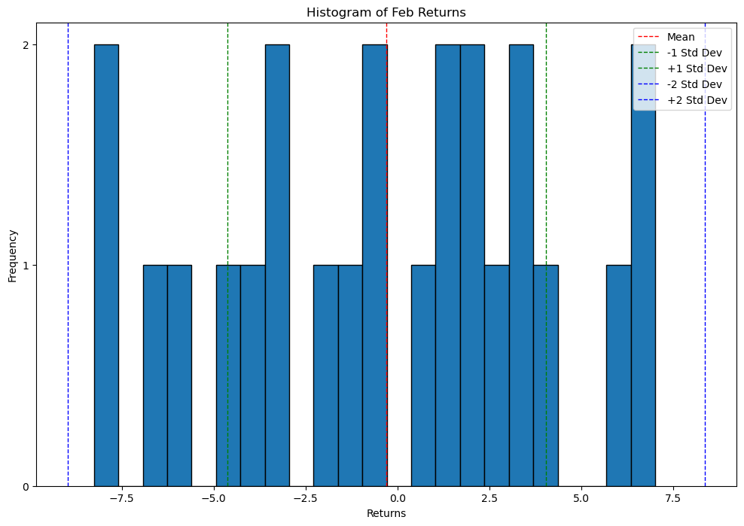Fig

Fig 6.2.4 Histogram plot for standard deviation bins of jan month

Fig 6.2.5 Histogram plot for standard deviation bins of feb month

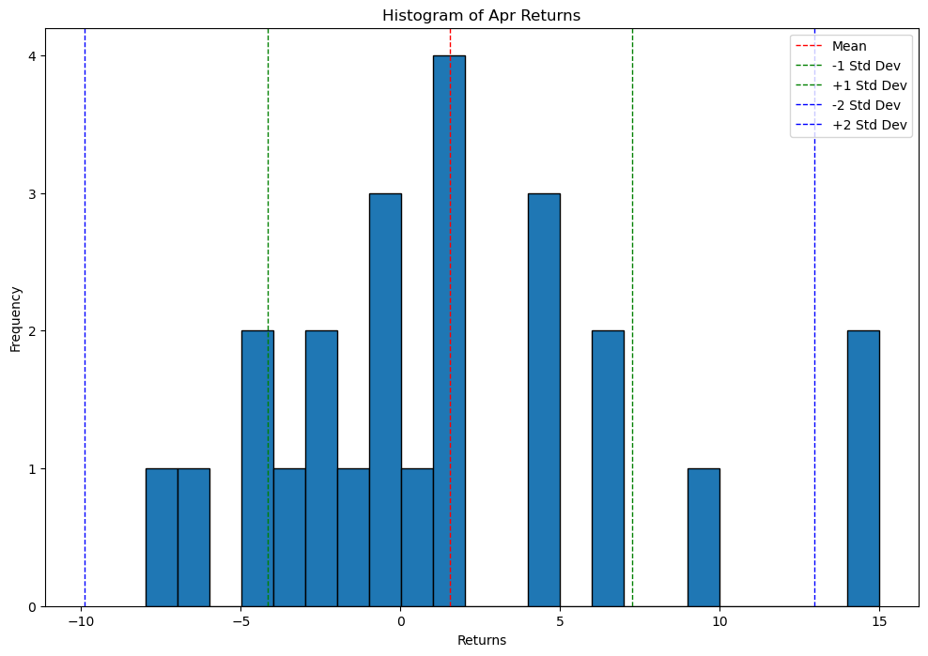

Fig 6.2.6 Histogram plot for standard deviation bins of apr month

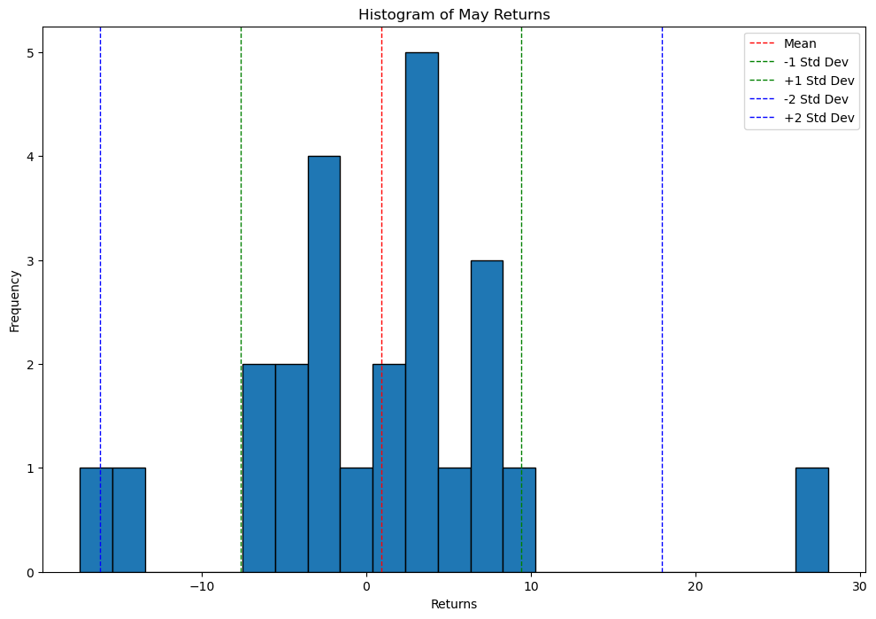

Fig 6.2.7 Histogram plot for standard deviation bins of may month

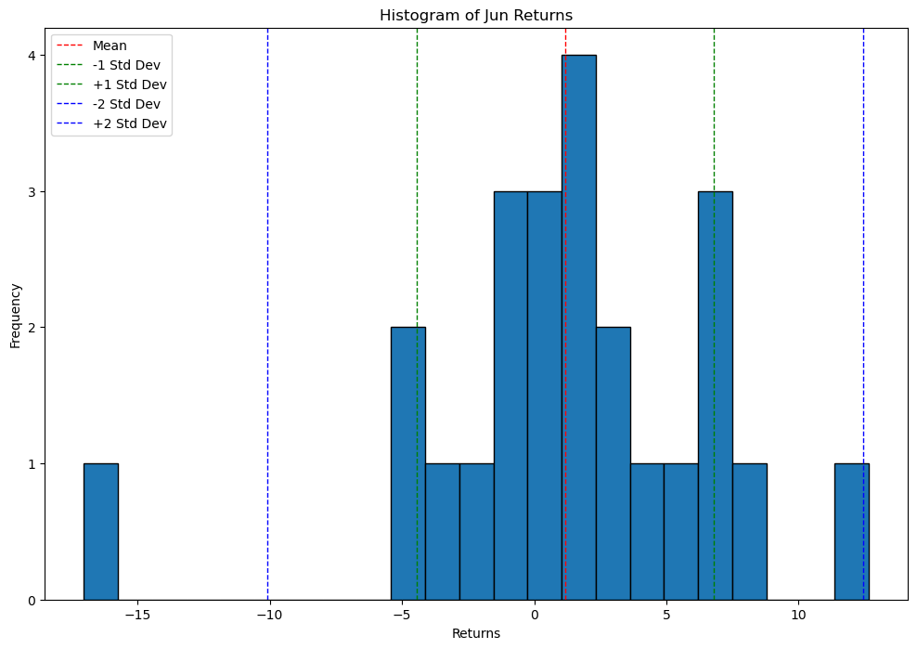

Fig 6.2.8 Histogram plot for standard deviation bins of jun month

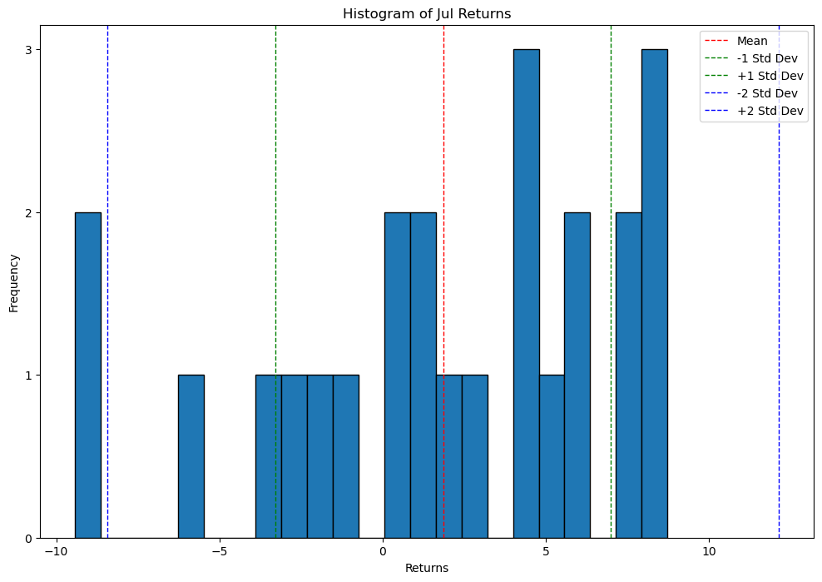

Fig 6.2.9 Histogram plot for standard deviation bins of jul month

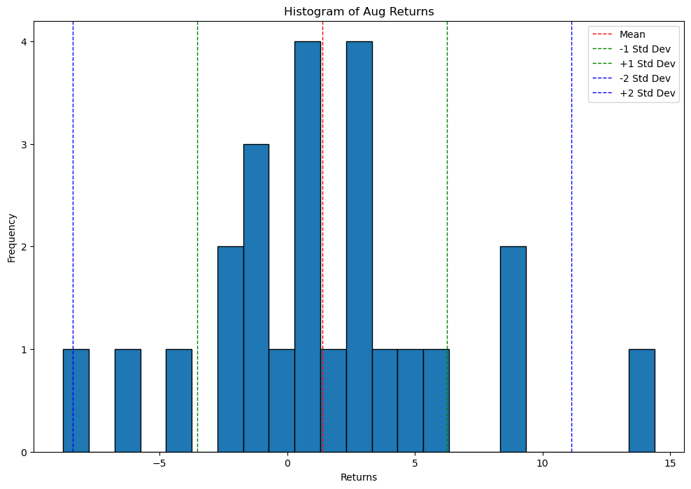

Fig 6.2.10 Histogram plot for standard deviation bins of aug month

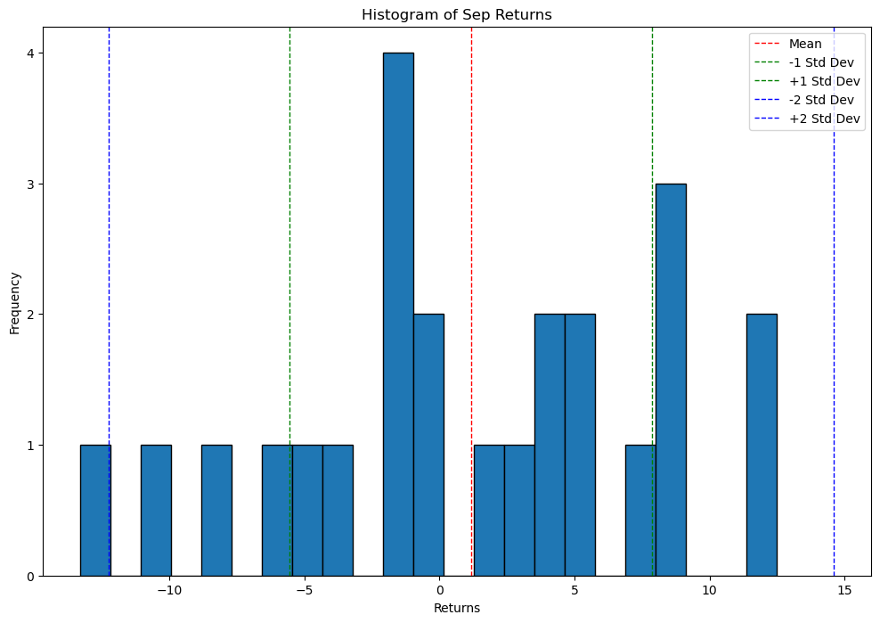

Fig 6.2.11 Histogram plot for standard deviation bins of sep month

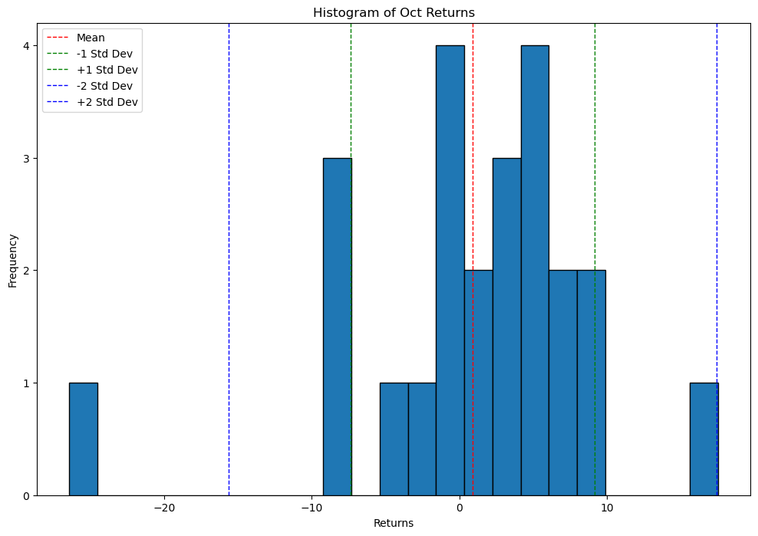

Fig 6.2.12 Histogram plot for standard deviation bins of oct month

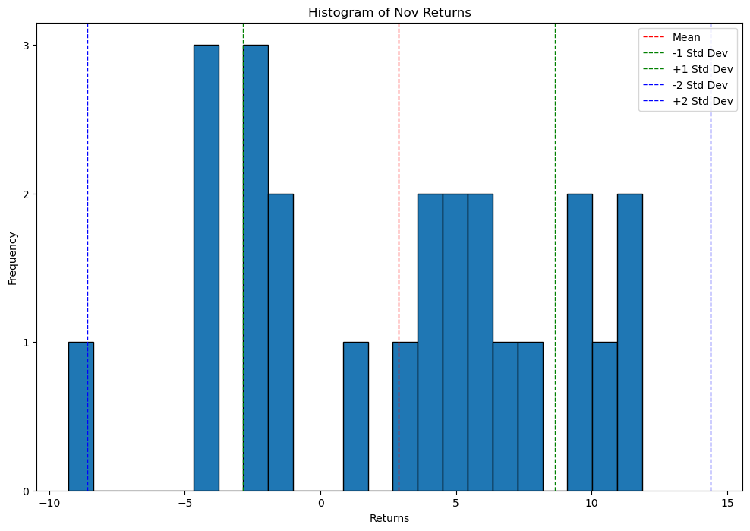

Fig 6.2.13 Histogram plot for standard deviation bins of nov month

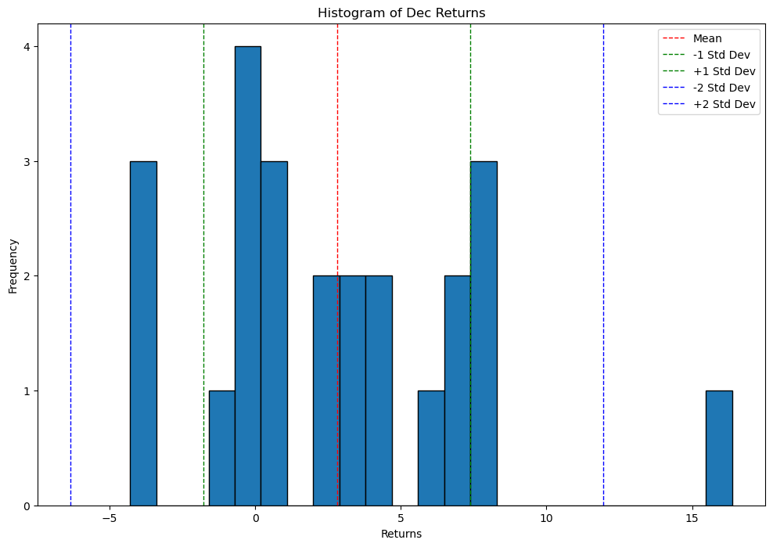

Fig 6.2.14 Histogram plot for standard deviation bins of dec month

**6.3** **Histogram for Annual returns**

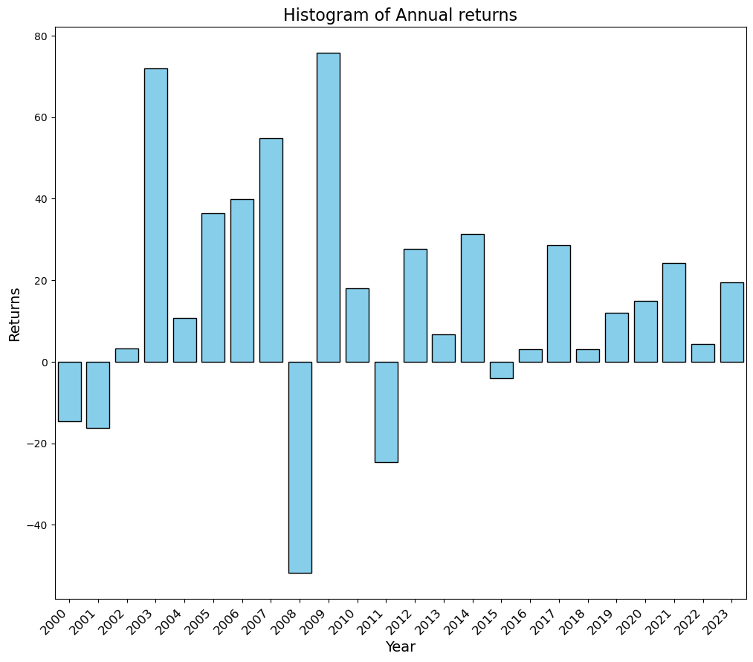

Fig 6.3.1 Histogram bar plot for annual returns

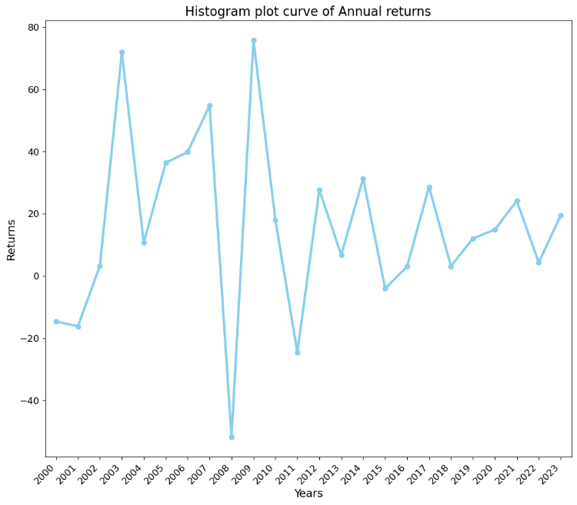

Fig 6.3.2 Histogram curve plot for annual returns

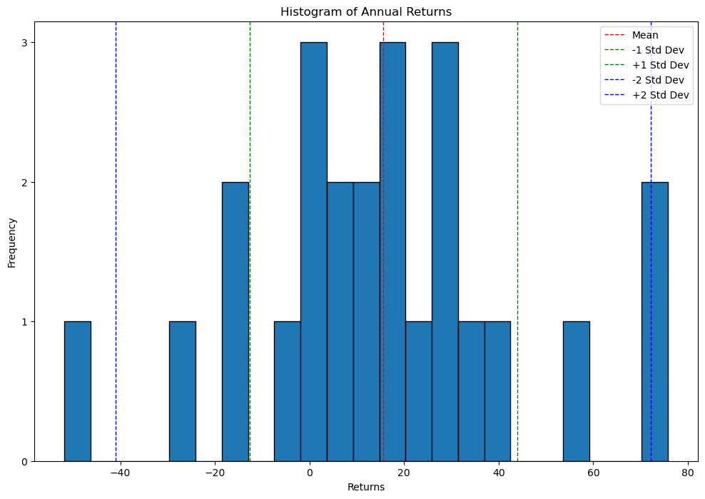Fig 6.3.3 Histogram standard deviation bins plot for annual returns

The annual feature in the dataset indicates the total return for each respective year. From the figures presented, it's evident that the year 2008 experienced a significant downturn in returns, while 2009 and 2003 displayed notably high returns. This observation is visually represented through bar plots and curve plots.

Furthermore, the analysis based on standard deviation bins reveals the following distribution:

Standard deviation less than 2: One-year Nifty return.

Standard deviation between -1 to +1: Seventeen years of Nifty returns.

Standard deviation between -1 to -2: Three years of Nifty return.

Standard deviation between +1 to +2: One year of Nifty returns.

Standard deviation greater than 2: One year with Nifty return.

This analysis provides valuable insights into the variability of Nifty returns across different years and standard deviation intervals, aiding in understanding market trends and risk assessment.

1. **Time series Analysis**

Time series analysis is a technique used to understand and analyse data collected over time, typically at regular intervals. It helps uncover patterns, trends, and relationships within the data, making it valuable for forecasting future values based on historical observations.

Time series analysis allows us to:

Identifying Trends which helps us understand if the data is exhibiting an overall increasing, decreasing, or stable pattern over time.

Detect Seasonal Patterns which enables us to uncover recurring patterns or fluctuations that occur at specific intervals for this dataset we did for monthly cycles.

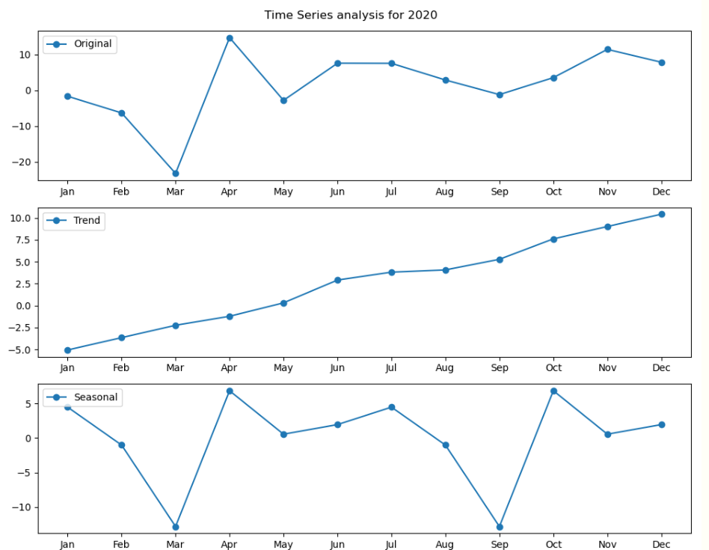

Fig 7.1 Trend, Seasonal plots for year 2020

Based on the analysis for the year 2020, it appears that the overall trend did not decrease significantly due to the COVID-19 pandemic; instead, it remained relatively stable and exhibited an increasing pattern.

However, the seasonal pattern shows distinct drops during the months of March and September, coinciding with the COVID-19 crisis. These drops suggest that the pandemic had a noticeable impact on the seasonal behaviour of the data during these specific months.

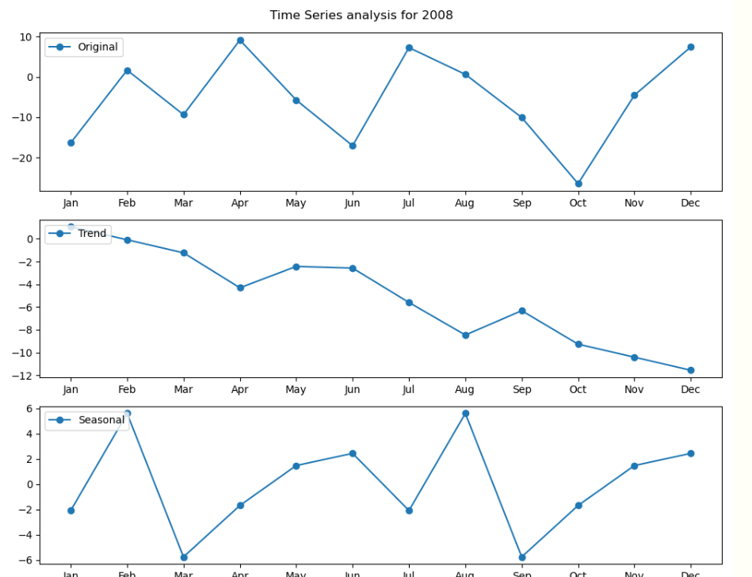

Fig 7.2 Trend, Seasonal plots for year 2008

For the year 2008, the trend of the data showed a noticeable decrease, indicating a downward movement over the course of the year. However, the seasonal component exhibited fluctuations, with periods of both increase and decrease throughout the year. Notably, the seasonal pattern was particularly affected in the months of March and September, showing significant deviations from the usual trend during these times.

However, following a similar analysis approach for the remaining years from 2000 to 2023, we observe various trends and patterns in the data. These include fluctuations in both trend and seasonality, with certain years experiencing significant deviations from the normal. Notably, the years impacted by external events such as economic crises or major events may exhibit distinct patterns compared to other years.

1. **Model Evaluation**

We build a model to generate forecasts for future years using the ARIMA (Auto Regressive Integrated Moving Average) model.

Parameter Selection

Autoregressive (p): This parameter represents the number of lag observations included in the model. It indicates how many previous time steps are used to predict the current value. A higher value of p means that more past observations are considered in the prediction.

Integrated (d): This parameter represents the degree of differencing applied to the time series data to make it stationary. It indicates the number of times the data needs to be differenced to remove trends and seasonality. A higher value of d means that more differencing is applied to make the data stationary.

Moving Average (q): This parameter represents the number of lagged forecast errors included in the model. It indicates how many past forecast errors are used to predict the current value. A higher value of q means that more past forecast errors are considered in the prediction.

We have found p using PACF (Partial Autocorrelation Function) and q using ACF (Autocorrelation Function)

d is initialised to 0 because the data is stationary it won’t change any more.

Once the ARIMA model is fitted to the time series data with specified values of p, d, and q, it uses these parameters along with the observed historical data to make forecasts for future time steps. The model combines the AR, I, and MA components to generate predictions, taking into account the relationships between past observations, differencing, and forecast errors.

As we define the number of years to predict the model is trained on historical data up to that specified year, including all months. This means that the model learns from the entire historical time series data available up to the end of the specified year, encompassing all months within each year.

1. **Building Web application**
2. Forecast Prediction Application:

* This application allows users to input the up to year and obtain forecasts for future time steps using an ARIMA model.

1. Histogram Plot Application:

* This application enables users to visualize the distribution of data using histogram plots.

1. Time Series Analysis Application:

* This application provides users with a comprehensive analysis of their time series data.
* These applications offer users the ability to explore and analyse time series data in different ways, providing insights into trends, patterns, and forecasted values.

By using Flask, we are using to route the webpages The Web application is developed using HTML (Hyper Test Markup Language), Javascript and CSS (Cascading Style sheet).

* 1. **Forecast Prediction Application**

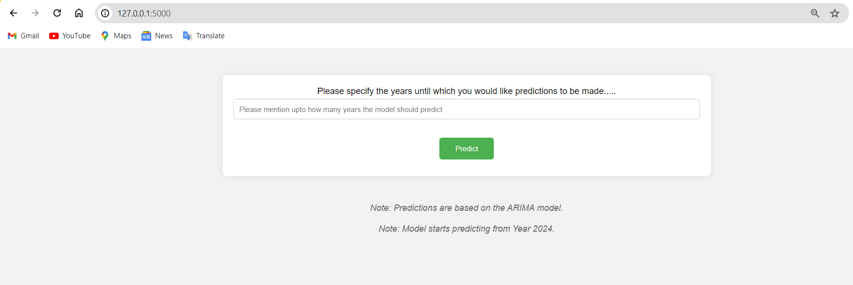

Fig 9.1 Input for Forecast Prediction Application

The user has to input the number of years which he/she wants to predict. Then the model predicts the forecast values.

* 1. **Histogram Plot Application:**

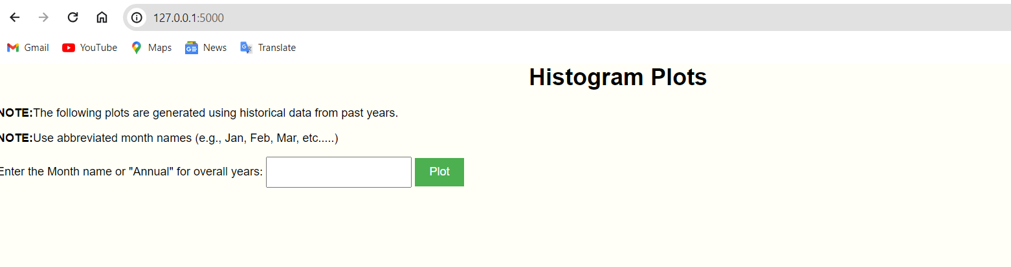

Fig 9.2 Input for Histogram Plot Application

As the user mentions the Month name or annual as input we get plots of histogram.

* 1. **Time Series Analysis Application:**

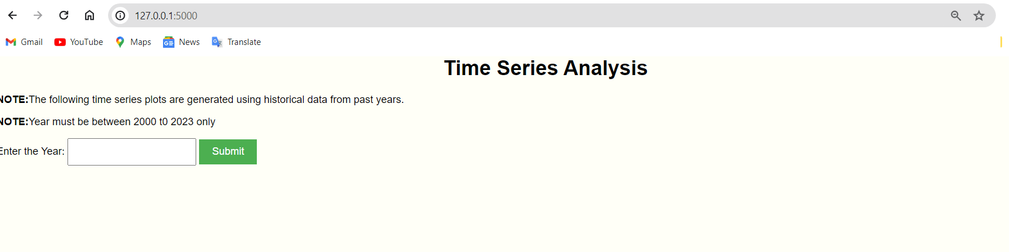

Fig 9.3 Input for Time Series Analysis Application

As the user mentions the Year according to it, we get plot graphs for trends, seasonal.

After taking inputs through web application, we created a new Python file to define Flask application and we defined routes for our applications. Here one route is used to render the form for users to input their data and another route to handle form submission and generate the result.

Flask routes which are defined to handle user requests, with one route rendering a form for inputting data and another route processing form submission, generating predictions, and displaying the result. The Flask application integrates with the trained models through a function to make predictions based on user input. HTML templates are used to design the user interface for inputting data and displaying predictions.



Fig 9.4 Running Flask application on localhost

When running a Flask application, the framework automatically assigns a port number for the application to listen on. By default, Flask uses port 5000. This means that when the Flask application is started, it will be accessible through a web browser using the appropriate port number. Accessing the application in a web browser would then be done by navigating to “http://localhost:5000”. The port number is crucial as it enables communication between the Flask application and the web browser, allowing users to interact with the web application seamlessly.

1. **. RESULT**



Fig 10.1 Web address of Flask Application

The URL "http://127.0.0.1:5000" you would be accessing a Flask web application running on your local machine through a web browser. Upon accessing this URL, web browser would display the home page in Flask application, allowing to interact with the web application's features and functionalities.

* 1. **Result for Forecast Prediction Application**

In your Flask web application, after the user inputs the number of years they want to predict, the application will use this input to generate forecasts using the ARIMA model. Once the forecasts are calculated, the application will return these predicted values to the result page, where the user can view them.

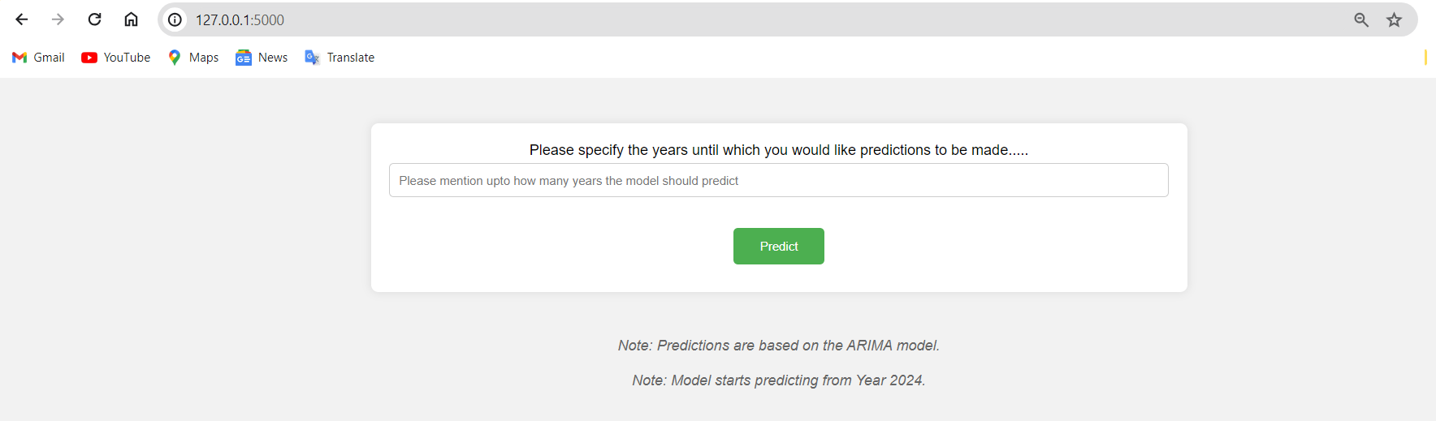

Fig 10.2 Input filed 1

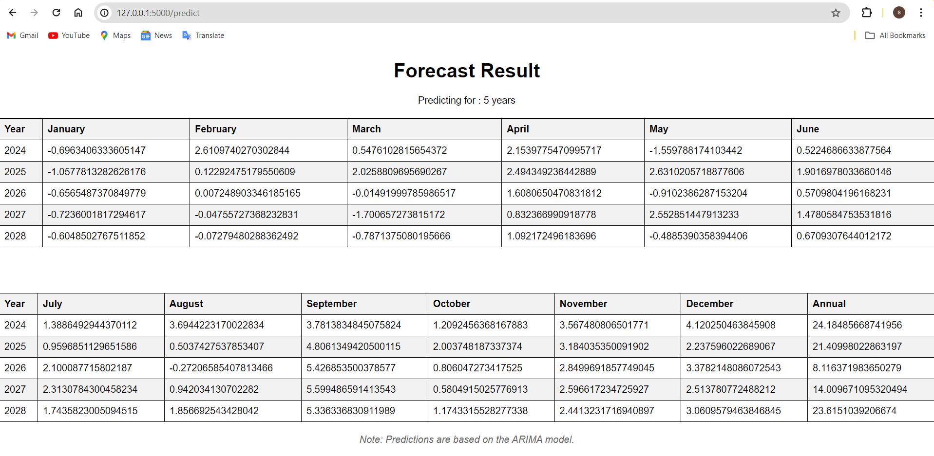The result for this we will be look like as follows:

Fig 10.3 output prediction 1

The ARIMA model calculates forecasts based on the historical data and the user's input (number of years to predict). Once the forecasts are generated, Flask application renders a result page and passes the predicted values to it.The result page displays the predicted values to the user. This could be done using HTML templates to format the predictions in a user-friendly manner.

* 1. 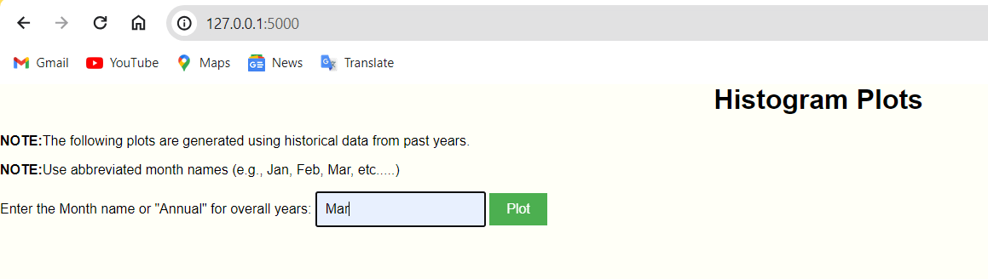**Result for Histogram Plot Application:**

Fig 10.4 Input filed 2

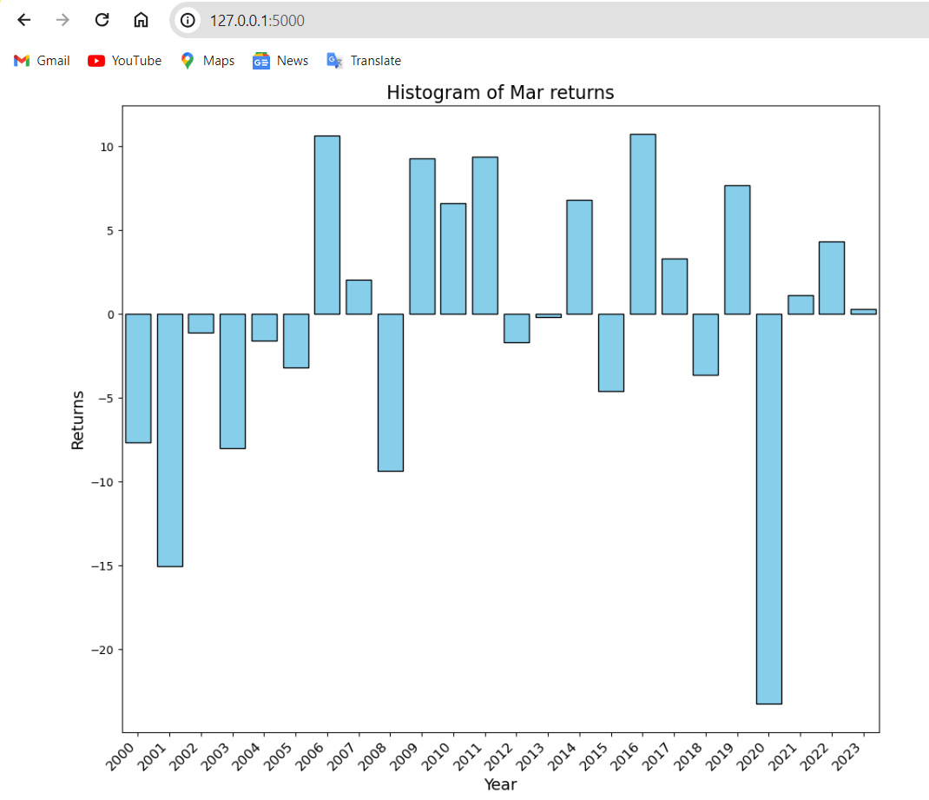

Fig 10.5 output prediction 2

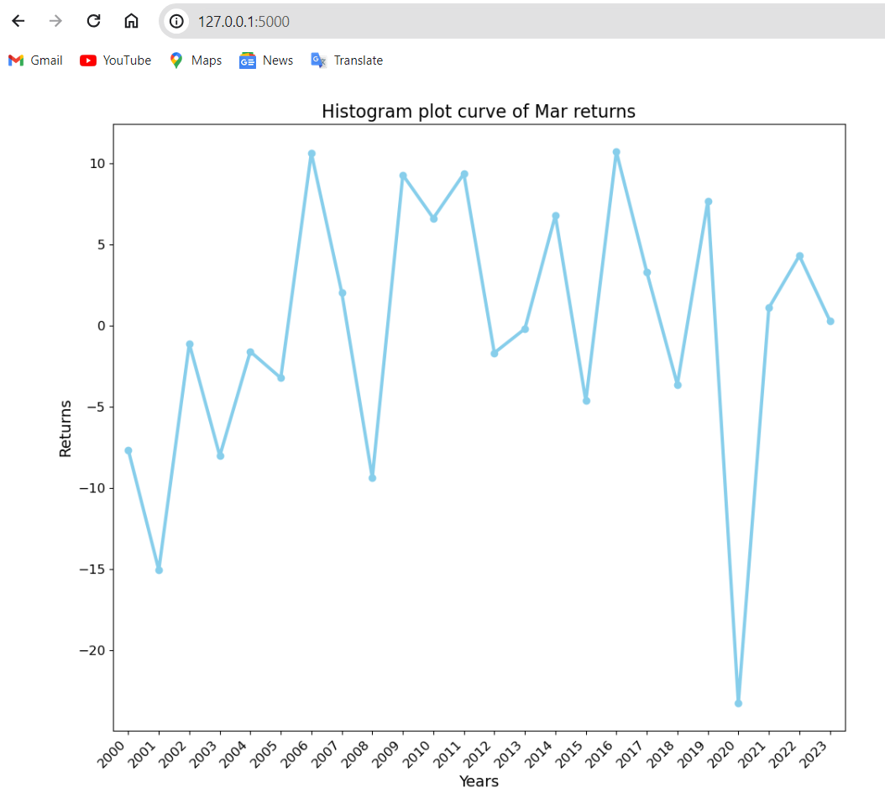

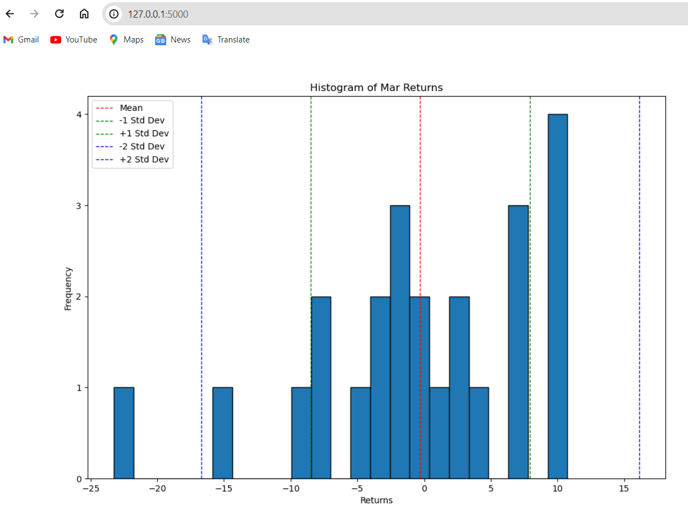Fig 10.6 output prediction 3

Fig 10.7 output prediction 4

These plots will be represented visually in result html page based on input selection.

* 1. **Result for Time Series Analysis Application:**

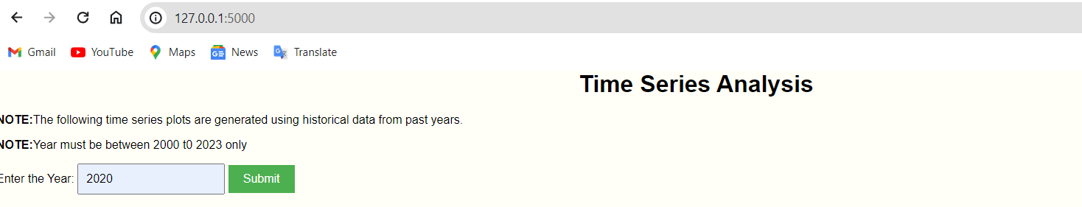

Fig 10.8 Input filed 3

Based on the input given the time series analysis plot will be visually given as result in result page.

Here 2020 is taken as input.

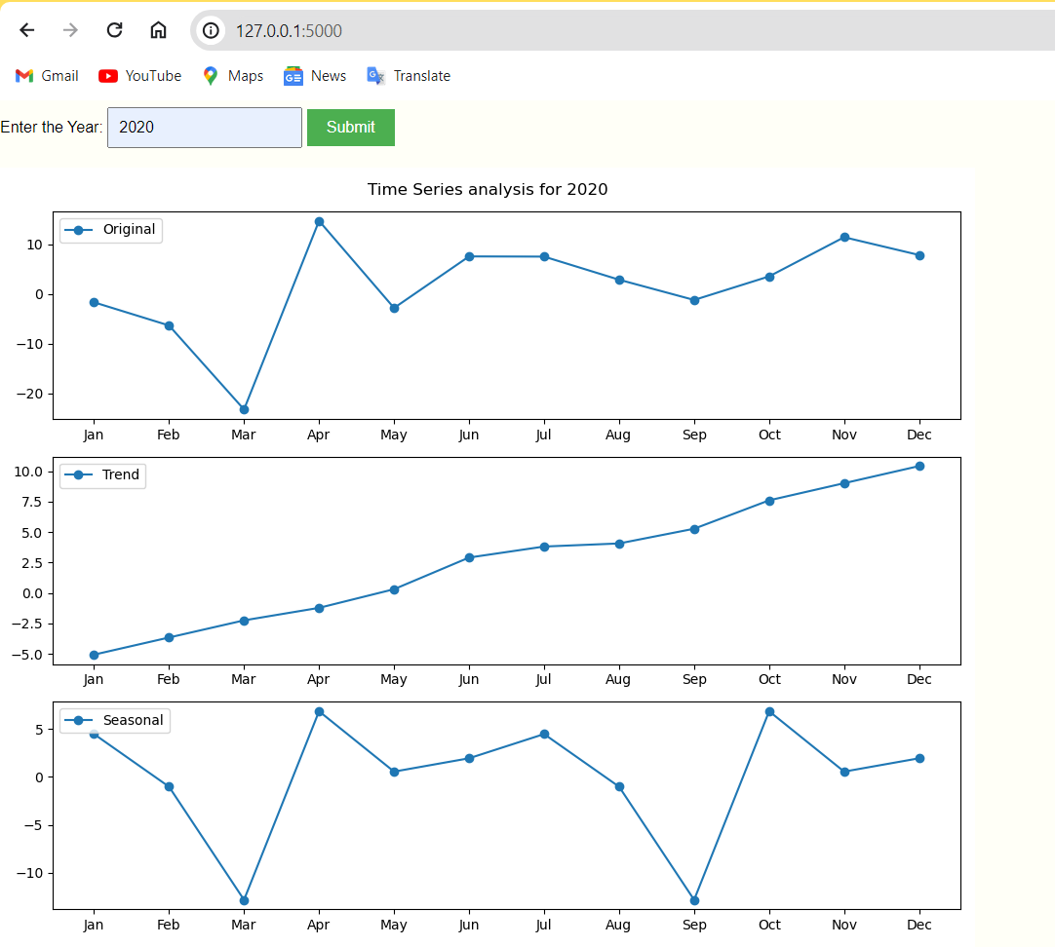

Fig 10.9 output prediction 5

As per the input given the time series analysis plot are plotted which shows trends, seasonality graphs or plots.

**11. Conclusion**

In conclusion, the exploratory data analysis and time series analysis conducted on the Nifty return’s dataset provided valuable insights into market trends and patterns spanning from January 2000 to December 2023.

The analysis revealed significant findings, including seasonal fluctuations, trends, and the impact of external events such as economic crises and the COVID-19 pandemic on Nifty returns.

Additionally, the development of forecasting applications using the ARIMA model facilitated predictive analysis, enabling users to make informed decisions about future market conditions.

Overall, the comprehensive analysis and web applications offer a robust framework for understanding and analysing Nifty returns data, empowering users with actionable insights for investment and financial planning strategies.

**12. References**

1. <https://trysakai.longsight.com/portal/site/520b8591-6130-4776-bf04-504e18e885f1/tool/e59fe5bb-2464-4b5c-9679-4d9af5857ede?panel=Main>
2. [www.youtube.com](http://www.youtube.com)
3. [www.google.com](http://www.google.com)
4. <https://primeinvestor.in/nifty-50-returns/>